**Biography: Tom Barrance**

Director of Learnaboutfilm.com

Speaker at the Bradford UNESCO City of Film International Film Education Symposium, 25 & 26 March 2019. For more information on this and other events [www.bradford.film](http://www.bradford.film)

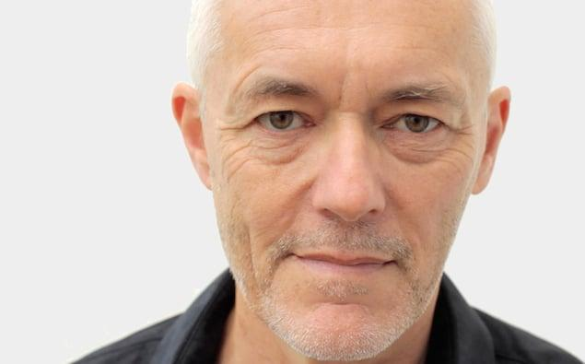

Tom is a film educator with over 20 years’ experience of teaching and supporting filmmaking in school, youth and community settings. He wrote the guides *Using film in schools, Primary filmmaking*and *Secondary filmmaking*and devised the interactive resources *Editshots* and *Making Movies Make Sense.*  
Tom has delivered numerous training sessions, workshops and teacher CPD introducing the essentials of filmmaking, film language, sound and editing. His recent work includes youth film projects for Kids in Museums; iPhone/iPad film training for researchers, charities and businesses; and school and community workshops in areas of social deprivation in South Wales. He runs the popular film education website [learnaboutfilm.com](http://learnaboutfilm.com/)

**For more information on the event or any other queries:**

* Contact David Wilson [david@bradford.film](mailto:david@bradford.film) (m) 07896729618 or Jane Hall [jane@bradford.film](mailto:jane@bradford.film)