**Biography: David Wilson**

Director, Bradford UNESCO City of Film

Speaker at the Bradford UNESCO City of Film International Film Education Symposium, 25 & 26 March 2019. For more information on this and other events [www.bradford.film](http://www.bradford.film)

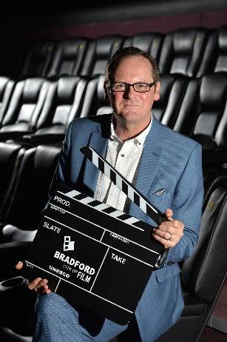

David Wilson is Director of Bradford UNESCO City of Film, where he represents the city on an international level as part of the UNESCO Creative Cities Network. Using the UNESCO title, David and his team work with many partners to bring about social and economic benefits for the people of Bradford and UK, to ensure all are realising the benefits of its status as the world’s first UNESCO City of Film. David is an international ambassador for the city, regularly speaking and presents at film, business and community events on Bradford’s film heritage and the city’s approach as a creative city, in addition to writing about film and presenting review shows on TV and radio. David represents the UK at an international level in relation to film and was one of the founding members of the UNESCO Creative Cities steering group, representing film. Since re-launching the Bradford Film Office in 2012 David and his team have brought hundreds of film and TV productions to the city. David was recently appointed Visiting Fellow in Film at the University of Bradford

David has a first class honours degree with a focus on culture and regeneration from the University of Bradford and is Director of the Small World Film Festival, the Bradford Family Film Festival and the Golden Years Film Festival. He is also a member of the advisory board at the Centre for World Cinema & Digital Cultures – University of Leeds, UK.

David is a professional musician and accomplished saxophonist with many years of experience performing live across the UK, Europe and in the US.

**For more information on the event or any other queries:**

* Contact David Wilson [david@bradford.film](mailto:david@bradford.film) (m) 07896729618 or Jane Hall [jane@bradford.film](mailto:jane@bradford.film)