**Biography: Karen Merkel**

Board member of UK Commission to UNESCO

Speaker at the Bradford UNESCO City of Film International Film Education Symposium, 25 & 26 March 2019. For more information on this and other events [www.bradford.film](http://www.bradford.film)

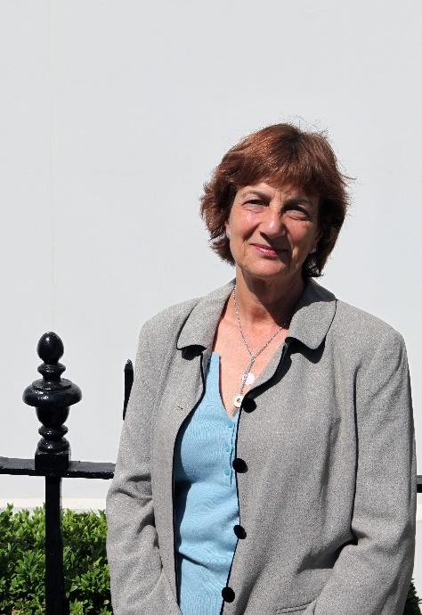

Karen Merkel has specialised in media production, consultancy and training in development for 30 years. She jointly set up New Media Networks (NMN) to partner with international agencies, broadcasters, media practitioners, academic institutions and communities globally. Previously, she assessed capital lottery bids for the Arts Council of England specialising in Cultural Quarters and digital developments, and produced the BFI’s Capital Development Plan. She also was Chair of Stratford Circus Arts Centre in East London for 4 years. She produced features for BBC Radios 4 and 5Live and started and co-ran SoundRadio – one of the first five Community Radio Stations with a UK Licence to broadcast. She worked for the BBC for nine years, directing projects for World Service Education and as Director of Education for the former World Service Trust (the BBC’s International Development arm) and directing strategy for BBC Worldwide Interactive Learning. She went on to run Amnesty International Secretariat’s Internet Programme, oversaw the launch of the new Amnesty website globally and introduced its first online debate. Karen has commissioned and led creative teams to deliver media programmes for broadcast and interactive platforms globally. She is an Associate Tutor for the practice based module of the Master’s Course in Media and International Development at the University of East Anglia in the UK.

**For more information on the event or any other queries:**

* Contact David Wilson [david@bradford.film](mailto:david@bradford.film) (m) 07896729618 or Jane Hall [jane@bradford.film](mailto:jane@bradford.film)