**Biography: Simona Manni**

Filmmaker

Speaker at the Bradford UNESCO City of Film International Film Education Symposium, 25 & 26 March 2019. For more information on this and other events [www.bradford.film](http://www.bradford.film)

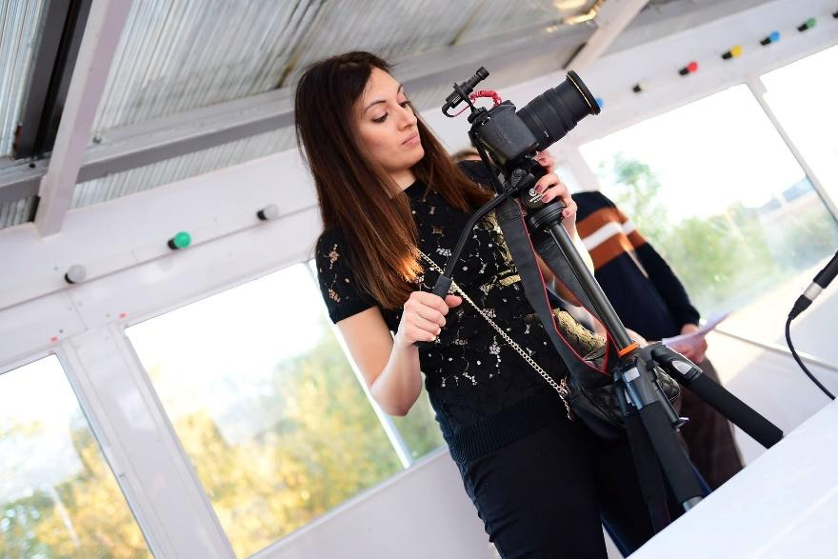

After studying film theory in Italy and documentary production in England, Simona started her work as a freelance filmmaker in York in 2012 and has produced educational, marketing, and event videos for a variety of local and national clients. Since 2015, she specialised in participatory filmmaking, where she uses expressive filmmaking with groups of people in community settings. Simona has a strong interest in how filmmaking can be used as a bridge to promote constructive and authentic communication between groups. She has designed inclusive participatory sessions, where, with her support, participants develop their own creativity by experimenting with filming techniques and using storytelling to explore their feelings and to communicate their viewpoints on relevant issues without having their voice mediated by an external filmmaker. Through this approach she has worked with a wide range of groups, including asylum seekers, people in recovery from mental health problems, homeless young people, women using support services, care home residents living with dementia. In 2018, Simona started a PhD at the Digital Creativity Labs, University of York, looking at developing interactive films in communities to discuss and explore issues related to mental health.

**For more information on the event or any other queries:**

* Contact David Wilson [david@bradford.film](mailto:david@bradford.film) (m) 07896729618 or Jane Hall [jane@bradford.film](mailto:jane@bradford.film)