**Biography: Mark Reid**

Head of Education, British Film Institute

Keynote speaker at the Bradford UNESCO City of Film International Film Education Symposium, 25 & 26 March 2019. For more information on this and other events www.bradford.film

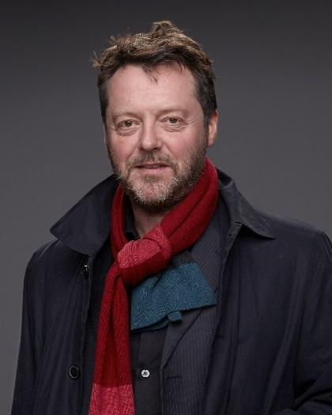

Mark trained as an English and drama teacher in the 1990s and taught in south London for seven years before joining the British Film Institute (BFI) as the Teacher Training Officer in 1998, where he set up distance learning MA programmes for media teachers, before taking over Education programmes at BFI Southbank in 2006. He is currently Head of UK Learning Programmes at BFI, overseeing the Schools and Families programmes. Over the last six years he has led research and curriculum development programmes with a range of partners, including Screening Literacy (2012), the first pan-European survey of film education; the European Framework for Film Education (2015); and Film: a language without borders (2018), creating a programme of cinema events in UK, Germany and Denmark for school groups with pupils of migrant background.

**For more information on the event or any other queries:**

* Contact David Wilson [david@bradford.film](mailto:david@bradford.film) (m) 07896729618 or Jane Hall [jane@bradford.film](mailto:jane@bradford.film)